|  |  |
| --- | --- |
| **Autumn Term Newsletter**  **St Clare’s Catholic Primary School**  **Parents’ Newsletter** | |
| Please remember school opens at **8:40am** every day.  If your child is in class after **8:50am** they are late. | |
| At St Clare’s, we continue to live, love, and learn together in the light and example of Christ. As a community, we are committed to nurturing every child spiritually, morally, and academically, helping them grow into the best version of themselves.  Welcome back to a new school year at St Clare’s Catholic Primary School! We hope you had a restful and joyful summer break. We are delighted with how well your children have settled back into school life, thank you for support us with this.  We look forward to working in partnership with you to support your child’s journey this year. Thank you for being part of our school family. | |
| **Do you have a child who will turn 3, 4 or 5 before 31st July 2026?**  We have spaces in Nursery for 3 and 4 year olds and in Reception for children turning 5 this academic year.  Please speak to the school office staff form application forms. | **Do you have a child in Year 6 ?**  Closing date for secondary school applications is Friday 31st October 2025  Please follow the link below for all the information you need.  If you need support in applying, please come and speak to the office staff.  Click here - [Secondary school applications](https://www.birmingham.gov.uk/info/20119/school_admissions/1778/apply_for_a_secondary_school_year_7_place/3) |
| **Uniform reminders**  **Thank you to all our parents who have worked hard to ensure that their children have started back to school in smart, correct uniform.**  Please see our full policy on the school website – [www.stclare.bham.sch.uk](http://www.stclare.bham.sch.uk)   * All children should be in smart black school shoes (or all black no branded trainers for P.E.) * Leggings of any sort are **not** part of the uniform. * Hair beads are **not** part of the school uniform. * Dyed hair or coloured weaves are **not** part of the uniform policy. * Earrings, if worn should only be small stud ones. * Please do not get lines cut into your child’s hair or eyebrows. * Hair bobbles should be blue, black, white or brown only. * Children **must** bring a coat to school during the winter months.   **Please label you child’s clothing – we are not responsible for any lost items of clothing.** | |
| <https://stclarescatholicprimaryschool.eschools.co.uk/web/governors/608741>  Please visit our school website for information about our curriculum, how to keep your children safe online and much more. | |
| **PARENTS AND CARERS WELCOME**  **English classes**  Every Friday 9:30am  All parents and carers welcome to come and improve their English.  **Craft classes** starting soon – all welcome.  Please let the office know if you are interested.  **Coffee afternoons**  Every Thursday 2pm – 3pm  Come and meet new people.  Everyone welcome.  Food Bank and pre-loved uniform and home clothes available in out parent hub – ask for Janet. | |
| **Catholic Social Teaching**  This term’s theme is Dignity of the Human Person    ‘Every single person in the world should be able to live a good life, with dignity, no matter what. We have dignity because God gave it to us.’ Pope Francis, Fratelli Tutti n107  We believe every human person is made in the image and likeness of God.  This is a gift that we all share as fellow human beings; we are all infinitely  loved by our Creator.  God is present in every human person, regardless of religion, culture,  nationality, orientation or economic standing. Each one of us is unique and  beautiful. We are called to treat every person and every creature with loving  respect. <https://www.youtube.com/watch?v=ABRl2ZSs58E> | |
| **Safeguarding**  **Dear Parents and Carers,**  At St Clare’s the safety and wellbeing of every child is our highest priority. We are committed to creating a nurturing environment where children feel safe, respected, and supported.  If you ever have concerns about a child’s welfare—whether at school, at home, or in the community—please speak to a member of our safeguarding team.  **Mr Hepburn, Mrs Kavanagh, Mr Murphy, Mrs Fahmi, Mrs Rivett**  All staff are trained in safeguarding procedures, and we work closely with external agencies to ensure every child receives the support they need.  Thank you for helping us keep our school a safe place for all. | |
|  | |

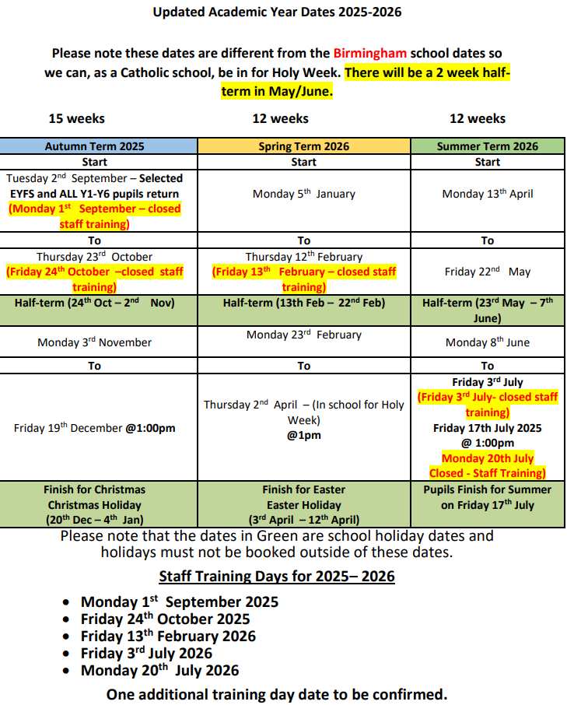

**Attendance Matters**

**Dear Parents and Carers,**

Thank you for helping your child come to school every day and on time. This is very important for their learning, happiness, and development. Being in school helps children do well and feel good.

When children come to school regularly, they:

Learn better

* Make friends
* Join clubs and trips
* Feel part of the school

**Why Attendance Matters**

The government, our school, and St Teresa of Calcutta MAC want to help all children come to school every day.

**The Law**

Children must go to school every day unless:

They are too sick

The school agrees they can be off for a special reason

If children miss school, they miss lessons. This affects their learning.

| Attendance | Days Missed | Weeks Missed | Lessons Missed |
| --- | --- | --- | --- |
| 95% | 9 days | 2 weeks | 45 lessons |
| 90% | 19 days | 4 weeks | 95 lessons |
| 85% | 29 days | 6 weeks | 145 lessons |

**Common Problems and What to Do**

Sometimes children don’t want to go to school. Here’s how we can help:

Children can still come with a cold, headache, or if they feel tired. If they get worse, we will call you.

Feeling worried: Please talk to us. We will help your child feel better about school.

Doctor appointments: Try to book them after school. If not, your child should come before or after the appointment.

Family problems: If things at home are hard, please talk to us. We will listen and help.

**Letting Us Know About Absence**

If your child is not coming to school:

Call school on 01215543289 and speak to a member of staff or leave a message telling us who your child is and why they are not in school.

If we don’t hear from you, we may visit your home to check everything is okay.

**Holidays in Term Time**

Children should not go on holiday during school time. If you want to ask for time off, you must ask before the holiday. We only say yes in special cases. If you take your child out without permission, you may get a fine.

**Our Attendance Policy** - We follow six steps:

We expect good attendance.

We check attendance data.

We listen to families.

We offer help.

We make a plan if problems continue.

We take legal steps only if nothing else works.

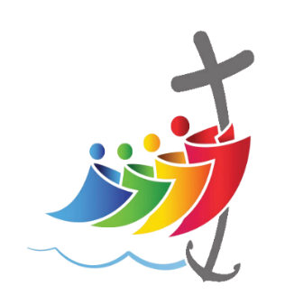

**JUBILEE 2025**

**PILGRIMS OF HOPE**

**Pilgrims of Hope**

**What is a Jubilee Year?** In the Catholic Church, a Jubilee or Holy Year is a special year of forgiveness and reconciliation in which people are invited to grow in their relationship with God, with one another and with all of creation.

**How often is a Jubilee Year?** A Jubilee Year is celebrated by the Church every 25 years. This has been the case since 1470 when Pope Paul II changed it from every 50 years.

**What is the theme of the Jubilee Year in 2025?** The theme is Pilgrims of Hope. Pope Francis has invited Catholics to renew our hope and discover a vision that can ‘restore access to the fruits of the earth to everyone’. We are also invited to rediscover a spirituality of God’s creation in which we understand ourselves as ‘pilgrims on the earth’ rather than masters of the world.

**When does the Jubilee Year start and finish**? The 2025 Jubilee Year begins on Christmas Eve 2024 and concludes on 6 January 2026.

**What is a Holy Door?** A Holy Door is one of the usually sealed entrances that lead into the major basilicas of Rome. The beginning of the Jubilee Year is marked by the opening of the Holy Door of St. Peter’s Basilica in the Vatican. It is only during a Jubilee Year that these doors are opened.

We are pilgrims of hope.

We walk in solidarity with our sisters and brothers worldwide, sharing challenges and celebrating joys.

We promise to be agents of change, working together for justice, love and peace, locally and globally.

We want to build a fairer world, where every person, and the earth, can flourish.

As pilgrims of hope, we are on a mission to build a world where:

 We recognise the dignity of every person, loved and created by God.

 We follow the example of Jesus’ love and his mission to bring good news ‘to the poor’. (Luke 4)

 We work for the common good of all, understanding that our actions impact our local and global family because we are all interconnected.

 We are good stewards of the earth, knowing that the earth’s gifts are for everyone, not just for a privileged few.

 We prepare a path to peace in our world, challenging the root causes of poverty and injustice.

 We speak out for debt relief, to set free those who are burdened by unjust debt.

 We work together with CAFOD and our local Caritas to be practical signs of hope and put love into action.