Dear Parent / Guardian
St Clare’s are hosting a FREE, engaging and fun-filled holiday club from Tuesday 2nd – Thursday 4th April from 9:30-2pm. Designed to provide a safe and stimulating environment for your child during the week, Bring it on Brum! holiday clubs guarantee your child an unforgettable experience packed with exciting activities and opportunities for learning and socializing.
Activities include sports and games, arts and crafts, cookery, dance and music. All clubs provide a nutritious and delicious meal too! Programmes vary depending on location.
Eligibility Criteria
If your child is aged between 4-16 and is eligible for benefits-related free school meals, then they are entitled to access Bring it on Brum! holiday clubs for FREE (there is a small charge for non FSM pupils but please book first and then arrange with the provider on the day).
Booking Information
Your Bring it on Brum! code is: 3303406 Please book via the Bring it on Brum! website at: www.bringitonbrum.co.uk.
All you have to complete the booking form is type in LEAP under Event Name: Type in LEAP and then search.
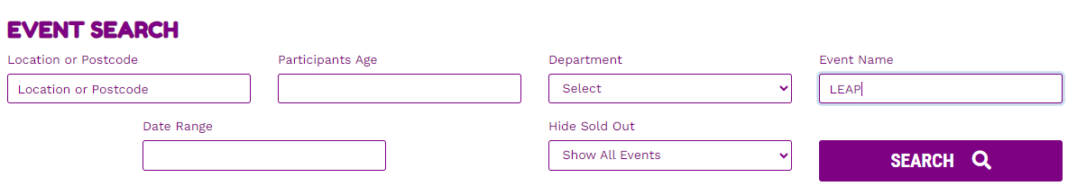

Then click on more information:
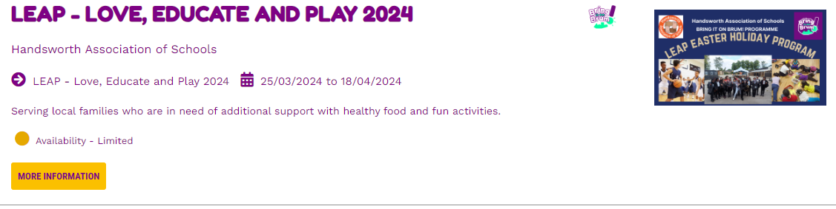

Scroll down to number 5 and then choose St Clare’s and BOOK Now - This is a quick and easy process:
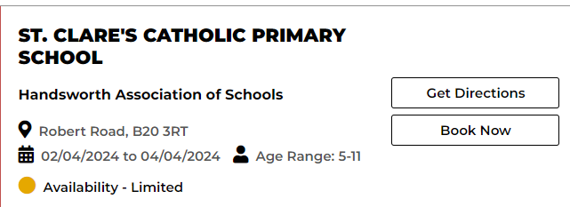
Remember the BIOB code is 3303406
We hope you make the most of this fantastic opportunity!
Warm regards
Mr Murphy

