As a school we have set up Google classroom for children to complete work at home. Please follow the small steps below to log on to the class page.
Step 1: Search Google classroom
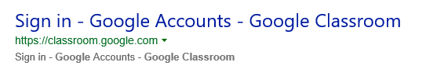
Step 2: Please ensure you click on the Manage teaching and learning Link as outlined below
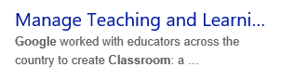
Step 3:
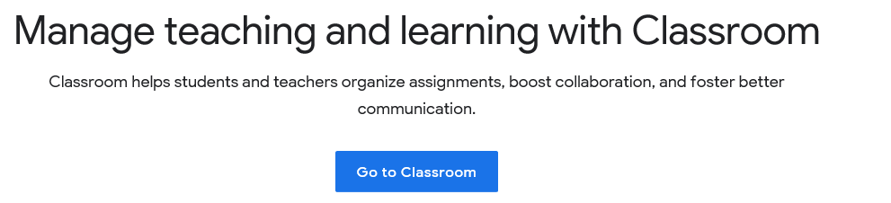
CLICK
Step 4: Login to personal email (please set up a google account if required).
Add Individual class joining code
This will be sent by Jotter as an individual code for each year group – Please do not access another Year group’s classroom. If you require a code then please email enquiry.

Your child’s learning is of course important to us, so we’ll continue to help your child to learn.
[Include details of your plan for continuing education remotely, such as:
- Google Classroom
- TT Rockstars and Numbots (Please see your child’s pack for login details)
- School website for links to a range of educational resources
Hard copies for work at home have been provided and an updated pack will be available every Friday starting from Friday 27th March between 9.30am – 12.30pm

On our school website under the PARENTS tab the first links are to 'Free Websites for Educational Use'. Please log in to our website over the school closure period as additional resources will be added regularly. Please forward questions to enquiry@stclare.bham.sch.uk

